Hotel Management System

# A Project Report

Submitted in partial fulfillment of the Requirements for the award of the Degree of

BACHELOR OF SCIENCE (INFORMATION TECHNOLOGY)

RITIK VISHWAKARMA

Seat Number: 19TIT159

Under the Esteemed Guidance of Mrs. Sumathi Rajkumar

Professor



**DEPARTMENT OF INFORMATION TECHNOLOGY NIRMALA MEMORIAL FOUNDATION COLLEGE OF COMMERCE & SCIENCE**

***(Affiliated to University of Mumbai)* MUMBAI-400101 MAHARASHTRA**

# 2021-22

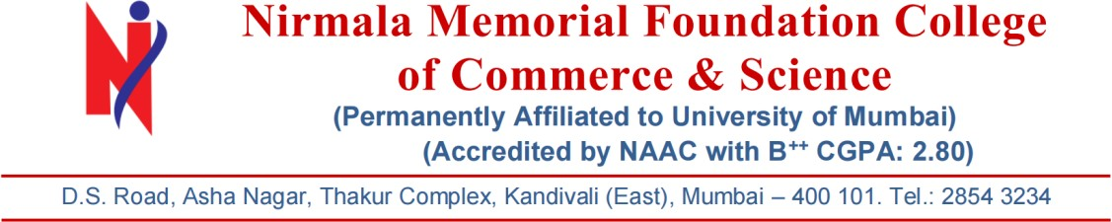

CERTIFICATE

This is to certify that the project entitled, **ONLINE BUS TICKET RESERVATION SYSTEM** is bonafied work of **ADITYA VISHWAKARMA bearing** Seat. No: **19TIT155** submitted in partial fulfillment of the requirement for the award of degree of BACHELOR OF SCIENCE in INFORMATION TECHNOLOGY from University of Mumbai.

PROF. VAISHALI MISHRA

Internal Examiner Coordinator

External Examiner

Date: College Seal

# PROFORMA FOR THE APPROVAL PROJECT PROPOSAL

PNR NO.: **…………………** Roll no:

1. Name of the Student

# ADITYA VISHWAKARMA

1. Title of the Project

# ONLINE BUS TICKET RESERVATION SYSTEM

1. Name of the Guide

# PROF. SUMATHI RAJKUMAR

1. Teaching experience of the Guide

# 10 YEARS

1. Is this your first submission?

**Yes** No

Signature of the Student Signature of the Guide

Date: **……………** Date: **……………**

Signature of the Coordinator Date: ……………………

ACKNOWLEDGEMENT

We would like to express our special thanks of gratitude to our professor **MRS. SUMATHI RAJKUMAR** as well as our principal **MS. SWIDDLE D’CUNHA** who gave me this wonderful opportunity to do this project on the topic **ONLINE BUS TICKET RESERVATION**

SYSTEM, which also helped me in doing a lot of research and I came to know about so many new things, I am really thankful to them.

Secondly, I would like to thank my parents and friends who helped me a lot in finalizing this project in the limited time frame.

**ADITYA VISHWAKARMA**

DECLARATION

I / We hereby declare that the project entitled, “**ONLINE BUS TICKET RESERVATION SYSTEM**” done at **NIRMALA MEMORIAL FOUNDATION**

COLLEGE, has not been in any case duplicated to submit to any other university for the award of any degree. To the best of my knowledge other than me, no one has submitted to any other university. The project is done in partial fulfillment of the requirement for the award of degree of BACHELOR OF SCIENCE (INFORMATION TECHNOLOGY) to be submitted as final semester project as part of our curriculum.

**ADITYA VISHWAKARMA**

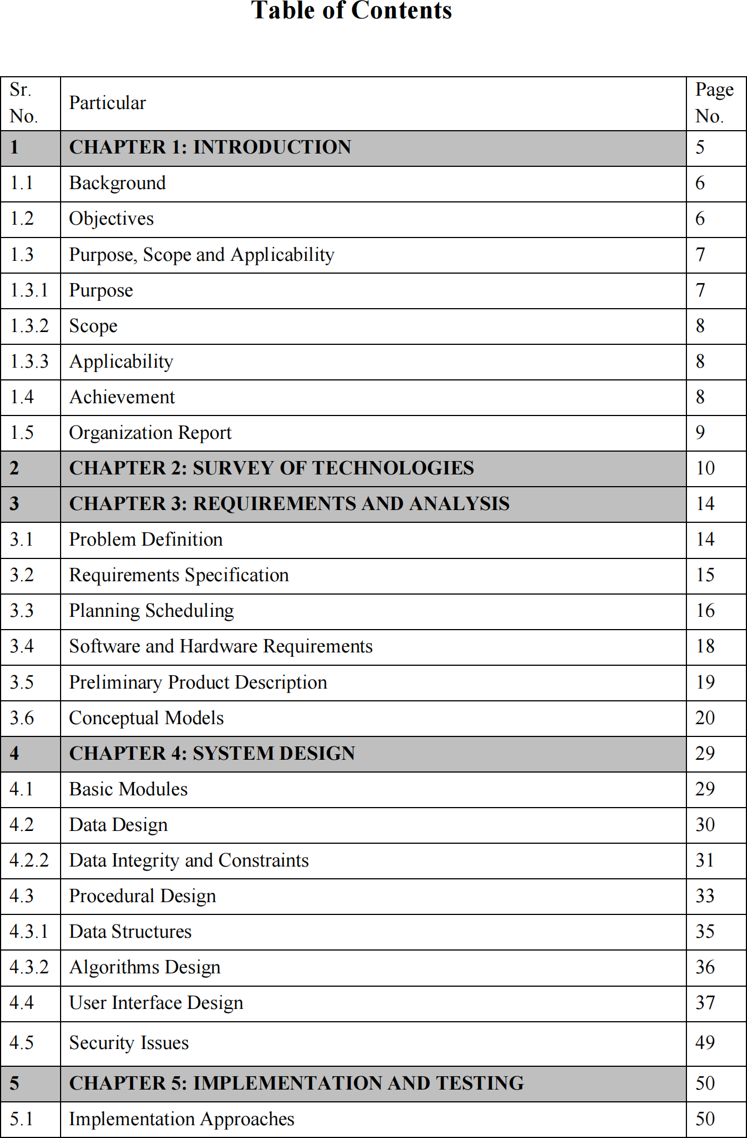

|  |  |  |
| --- | --- | --- |
| 5.2 | Coding Details and Code Efficiency | 51 |
| 5.3 | Testing Approach | 56 |
| 5.3.1 | Unit Testing | 56 |
| 5.3.2 | Integrated Testing | 56 |
| 5.3.3 | Beta Testing | 57 |
| 5.4 | Test Cases | 57 |
| 6 | CHAPTER 6: RESULTS AND DISCUSSION | 59 |
| 6.1 | Test Reports | 59 |
| 6.2 | User Documentation | 60 |
| 7 | CHAPTER 7: CONCLUSIONS |  |
| 7.1 | Conclusion |  |
| 7.1.1 | Significance of the System |  |
| 7.2 | Limitations of the System |  |
| 7.3 | Future Scope of the Project |  |
|  | REFERENCES |  |
|  |  |  |